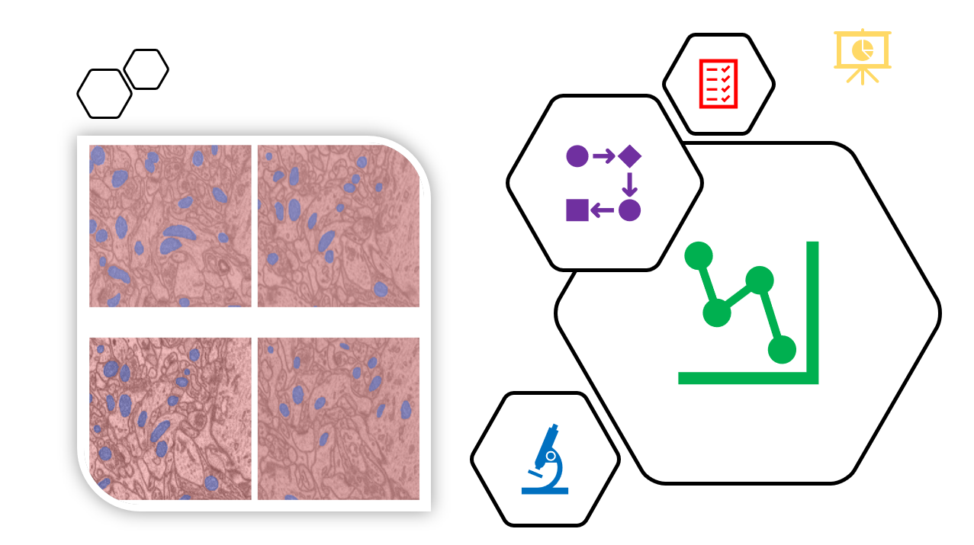

Biological labs use several experimental techniques and instruments to analyse their samples. These techniques output vast quantities of data daily that requires to be processed. This is going to get even more complicated as the hardware improves and the need for sophisticated data processing is paramount.

On a fundamental level, research is performed in an iterative manner which as be summarised in a closed cycle where data is collected, pre-processed, analysed and compared.

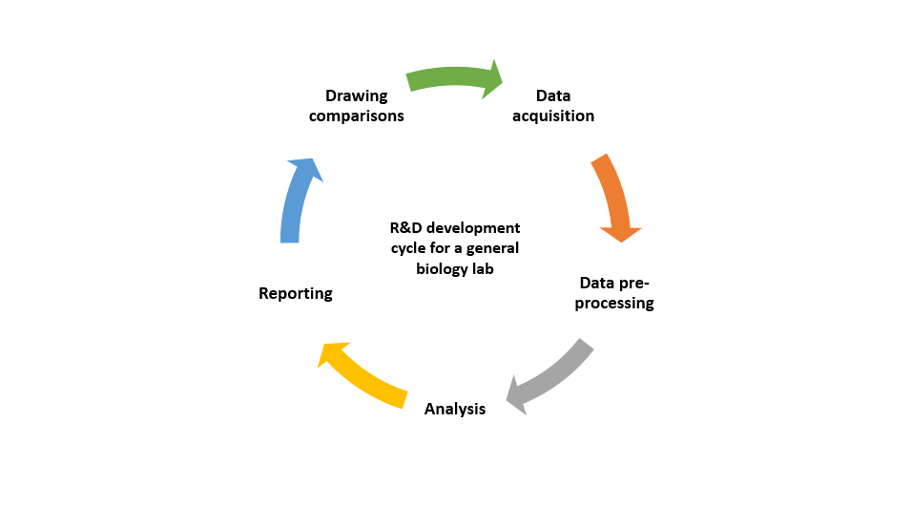

To maintain the competitive edge and iterate as quickly as possible, automation is required. Across the entire cycle several hours of research time is lost due to bottlenecks related to manual tasks.

However, with recent developments in machine learning and deployment frameworks, it is possible to create robust end to end analysis pipelines rapidly. Such approaches aim to centralise the majority of the analysis behind a web interface with a script that does the analysis in the background.

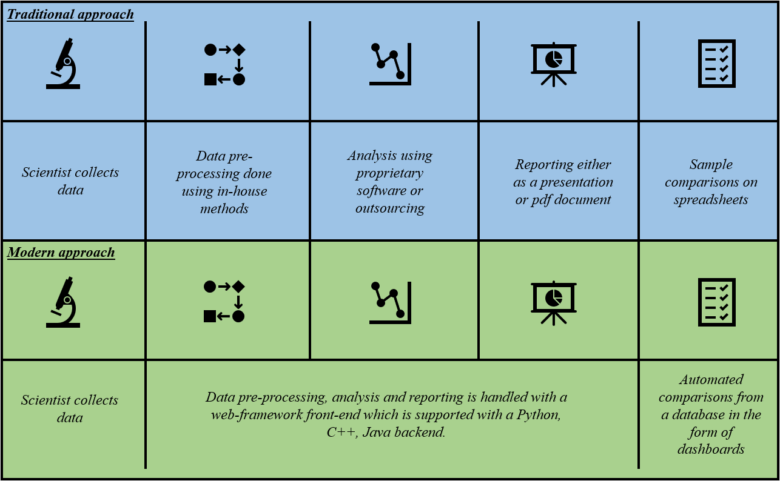

In this project I demonstrate an app where the data pre-processing, analysis and reporting is automatically handled with a combination of machine learning and “classical” image processing. The example app